FEATURED PROJECT

Baton Rouge, Louisiana South Wastewater Treatment Plant

Project Location

Baton Rouge, LA
South Wastewater Treatment Plant
205 MGD Preliminary Treatment System

Installed:
Engineer: Contractor:
2013
CDM Smith
Brasfield & Gorrie

Featuring

WWTP Plant Upgrade Achieves 98% Grit Removal with PISTA® 360™
S&L Equipment Overview

- 6 Model 50F PISTA® 360™ with
V-FORCE BAFFLE™ Units

- 5 Service Units; 1 Stand-by Unit

- Designed for 41 MGD per Unit

- Patented Hydraulic Vortex with
Internal Flow Control Baffling

- 360° Flat Floor Chamber Design

- 316 Stainless Steel Wetted Parts
(Drive Tube, Propeller, Floor Plates, Fluidizer)

- 28’ Diameter per Unit
ome to the state capital, two major universities, several Fortune 1000 companies, and a rich cultural heritage, the City of Baton Rouge is one of America’s most dynamic, growing cities. “Red Stick” dates back to 1699 when Europeans began settling there and establishing military strongholds as early as 1719. Today, and seven national flags later, the City serves as the seat of Louisiana’s most populated parish, East Baton Rouge (pop. 440,171), and the center of a burgeoning metropolitan area of more than 800,000.
H

Historically, the unified City-Parish Department of Public Works has operated three different wastewater treatment plants, North, Central, and South. Since 2008, the City-Parish has undertaken monumental capital improvements to expand its wastewater collection and treatment infrastructure. Plans called for the eventual decommission of its Central Plant and diverting its flows to an expanded and upgraded South Plant (SWWTP). The City-Parish estimates than more than $36 million per year will be saved in future long-
term capital and operational costs with Central’s closure and consolidation.
Grit Test Results

Conducted: July 2014
Total In: 679 g
Total Out: 14 g
Removal Efficiency: 97.9%
Down to 140 mesh / 105 micron

2 Hp Drive Unit—PISTA® 360™
For project inquiries and complete
technical support, contact Smith & Loveless by phone (800) 898-9122 or online at smithandloveless.com.
In order to handle the increased capacities, several segments of the SWWTP required significant overhaul and expansion, accomplished in three major improvement projects. The second of theseprojects includes anew 205 MGDpreliminarytreatment system. Phase I, designed by CDM Smith (Baton Rouge), went online in March 2013 and features a more efficient screening and grit removal system with larger capacity. The entire facility isdivided into six 41-MGDtrains, includingsix PISTA® 360™ Grit Chambers each equipped with a patented V-FORCE BAFFLE™.
continued on page 2

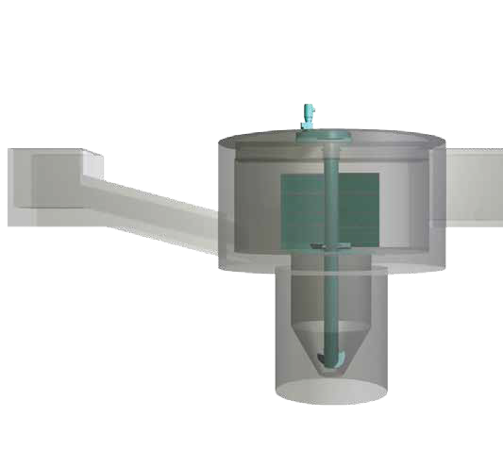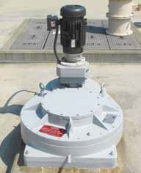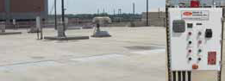

Featured Project - Baton Rouge, Louisiana South Wastewater Treatment Plant - Page 2

S&L provides six grit chambers as part of new 205 mgd preliminary treatment facility

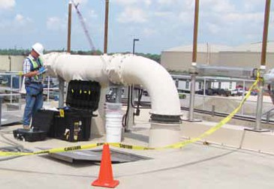Grit removal is a necessary investment for the plant in order to protect the downstream equipment from abrasion. With a history of sanitary sewer overflows and build-up in its primary settling tanks from poor performing headworks, reliable performance over a range of daily flows was essential. Specifications called for removal efficiencies of 95 percent. Given its experiencewith large flow systems, project leader Phillip Gibson, P.E., turned to Smith & Loveless. With more than 2,500 PISTA® installations, including hundredswithindividualcapacitiesof 50 MGDandgreater, Smith& Loveless offered the right expertise and equipment to assist in this project.

Beyond S&L experience, PISTA® technology offered specific benefits to fit theneedsoftheproject. Highremovalefficiencies originate fromthe PISTA® 360™ Grit Chamber’s hydraulic design, including its flat chamber floor,

The PISTA®

360™

Grit Chambers at SWWTP tested at 98% removal efficiency

internal baffling and low-energy axial-flow propeller. Thesystem’s patented V-FORCE BAFFLE™ is an integral flow control device for both the inlet and outlet of the chamber. It directs the inlet flow into the chamber, ensuring the proper vortex flow. This sweeps the grit along the flat floor toward the center opening of the lower grit storage hopper. The baffle allows for a full 360° flow rotation and provides maximum travel for the most effective grit removal. In the outlet, the V-FORCEBAFFLE™ directs the flow out of theunit and acts as a “slice weir” to control the water level in the main chamber and in the inlet channel. No additional downstream flow control device is required to keep the velocity between 3.5 fps (1.1 mps) at peak flow and 1.6 fps (.5 mps) atminimumflowwitha 10:1 turndown. By increasing chamber velocity during low flow periods, the baffle extends the grit extraction path within the vortexing grit chamber.

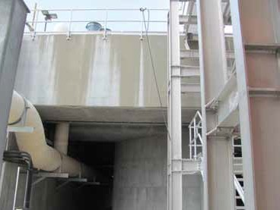
These PISTA® 360™ Grit Chambers feature 316 stainless steel wetted parts.
down to the critical particle size of 140 mesh / 105 micron.

Initial Grit Test Results
Although all phases of the SWWTP improvement will be completed at the conclusionof 2014, thenewpreliminarytreatmentsystemhasbeenonlinefor morethanayearwithpartialflows. In July 2014, grit testing wasundertaken to evaluate the incoming grit into the plant, and the removal efficiency performance of the new PISTA® system. Samples were taken over multiple days in the inlet and outlet channels utilizing thorough Cross-Channel Sampling methodology. The average daily flow was 23.8 MGD.

The overall results of the sampling are summarized in the table below, which demonstrates highly efficient removal results. A healthy amount of grit was collected across the inlet (nearly 680 g) to ensure that reliable testing could be established. Likewise samples were collected in the outlet. Thecumulative results demonstratedexcellent removal efficiency of 97.9% down to 105 micron / 140 mesh particle size.
Brochure #9103-6 © 2014 Smith & Loveless Inc.
Grit Testing Results Conducted July 2014 / 23.8 MGD Avg. Flow

Test | Result
Total In | 679 g
Total Out | 14 g
Removal  Efficiency | 97.9%*
* Down to 140 mesh / 105 micron

Online: smithandloveless. com • Phone: 913 . 888 . 5201 • Fax: 913 . 888 . 2173
Offices in Metropolitan Kansas City | Los Angeles | Atlanta | London | Auckland

